**Assignment 1**

Q1. Write matlab/octave code to compute the following

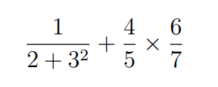

Q2. Explain the difference between the commands ‘format short’ and ‘format long’ with examples

Q3. Write matlab/octave code to compute the following. Choose a value for variables ‘a’, ‘x’, ‘y’



Q4. Write a matlab/octave code to create a ‘column vector’. Perform ‘transpose’ operation and

display the vector

Q5. Write a matlab/octave code to create a 3x3 matrix. Display the 2nd and 3rd column of the

matrix.

Q6. Write a matlab/octave code to generate the following number sequence

0.0, 0.1, 0.2, 0.3, 0.4, 0.5, 0.6, 0.7, 0.8, 0.9, 1.0

**Date & Time of submission: 12-10-2021 (5PM)**

**Link to upload: (Batch B)**

<https://amritavishwavidyapeetham-my.sharepoint.com/:f:/g/personal/s_sachinkumar_cb_amrita_edu/ElR-qIzC_9hHpMlsZootNXkBy5934n7qBnVa-iDsz0GfOQ?e=nm0uWq>

**Note:**

**1. Place the code and screenshot of output below the questions**

**2. Rename the file as “A_Name.docx’ before uploading to the above link**